CSA1715 – ARTIFICIAL INTELLIGENCE
P.SAI SWETHA 192324011

LAB EXPERIMENTS:

EX – 1 :

8-Puzzle Problem
Aim
To solve the 8-Puzzle problem using the A* search algorithm in Python.
Algorithm
- Define the initial state and goal state.
- Calculate the heuristic value (number of misplaced tiles or Manhattan distance).
- Store the puzzle states in a priority queue.
- Select the state with the lowest evaluation function.
- Generate all possible moves (up, down, left, right).
- Calculate the cost for each new state.
- Repeat until the goal state is reached.
- Display the solution path.
Python Program

from heapq import heappush, heappop

goal = [[1,2,3],[4,5,6],[7,8,0]]
start = [[1,2,3],[4,0,6],[7,5,8]]

def h(s):
return sum(abs(i-(v-1)//3)+abs(j-(v-1)%3)
for i,r in enumerate(s)
for j,v in enumerate(r) if v)

pq = [(h(start), 0, start)]
visited = []

while pq:
f, g, s = heappop(pq)
if s == goal:
print("Goal State Reached")
for r in s:
print(r)
break
if s in visited:
continue
visited.append(s)

x, y = [(i,j) for i in range(3) for j in range(3) if s[i][j]==0][0]

for dx, dy in [(-1,0),(1,0),(0,-1),(0,1)]:
nx, ny = x+dx, y+dy
if 0<=nx<3 and 0<=ny<3:
t = [r[:] for r in s]
t[x][y], t[nx][ny] = t[nx][ny], t[x][y]
heappush(pq, (g+1+h(t), g+1, t))

output :

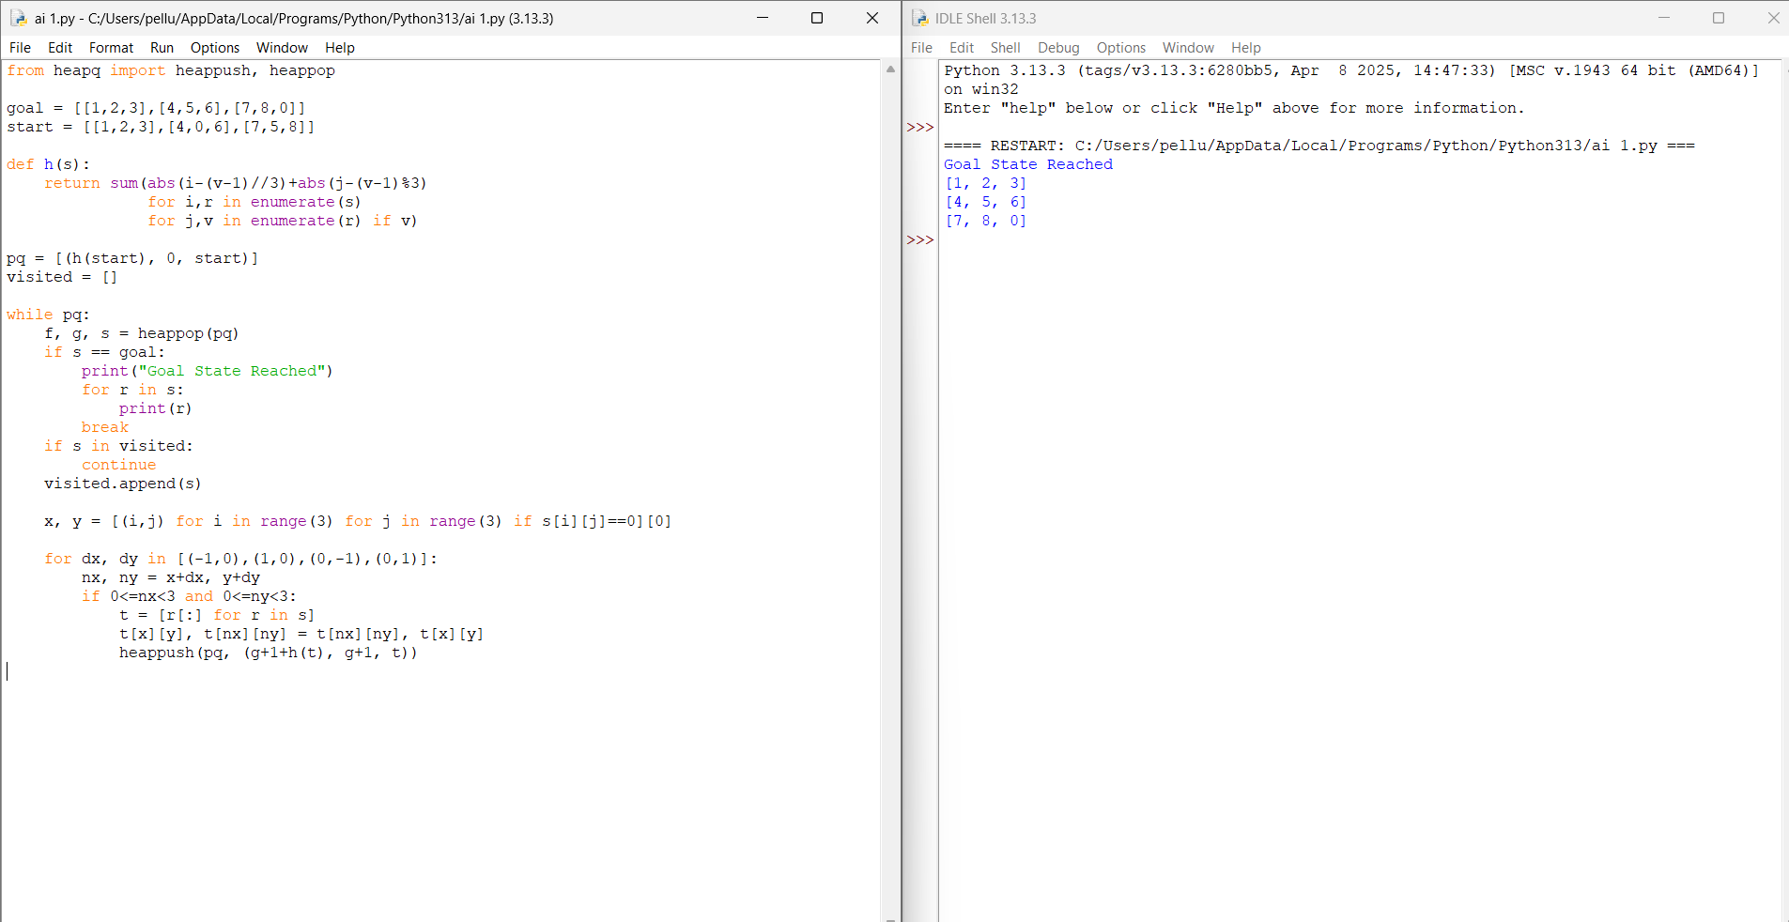

Result :
The 8-Puzzle problem was successfully solved using the A* Search algorithm. The program generated the sequence of moves and reached the goal state efficiently by selecting the state with the lowest heuristic value.

